The quiet town nestled between rolling hills was the perfect escape from the hustle and bustle of city life. Narrow cobblestone streets wound through rows of charming cottages, each with vibrant gardens bursting with color*. the air smelled of fresh flowers and earth after a recent rain, and the distant hum of nature filled* **THE ATMOSPHERE. BIRDS FLITTED BETWEEN TREES, THEIR SONGS ECHOING SOFTLY THROUGH THE VILLAGE,** WHILE Squirrels Scurried Playfully Along The Tree Branches. It Felt As Though The Town Had ~~stepped out of another time, where the pace of life was slower, and the pressures of modern existence barely touched its peaceful rhythms.~~ **~~(~~34567)2 (456776)5**

1. People greeted each other with warm smiles and genuine curiosity, taking the time to chat about their days or offer advice about where to find the best local produce. The town was small, but there was a certain charm in its simplicity. You could walk from one end to the other in less than half an hour, yet there was always something to discover. The bakery at the corner had the best apple pies, and the old bookshop on Maple Street, with its weathered wooden shelves, was a hidden gem for those who loved to lose themselves in the pages of forgotten novels.

* In the afternoon, the square in the center of town became a hub of activity. Children ran about playing tag or chasing after the ice cream truck that parked by the fountain, its cheerful music ringing out across the cobblestones. Elderly residents, who had lived in the town their entire lives, sat on park benches under the shade of ancient oak trees, chatting quietly or simply watching the world go by. There was a sense of contentment in the air, a feeling that things didn’t need to be rushed to be appreciated.

|  |  |  |  |  |  |  |  |  |  |
| --- | --- | --- | --- | --- | --- | --- | --- | --- | --- |
|  |  |  |  |  |  |  |  |  |  |
|  |  |  |  |  |  |  |  |  |  |
|  |  |  |  |  |  |  |  |  |  |
|  |  |  |  |  |  |  |  |  |  |
|  |  |  |  |  |  |  |  |  |  |
|  |  |  |  |  |  |  |  |  |  |
|  |  |  |  |  |  |  |  |  |  |
|  |  |  |  |  |  |  |  |  |  |

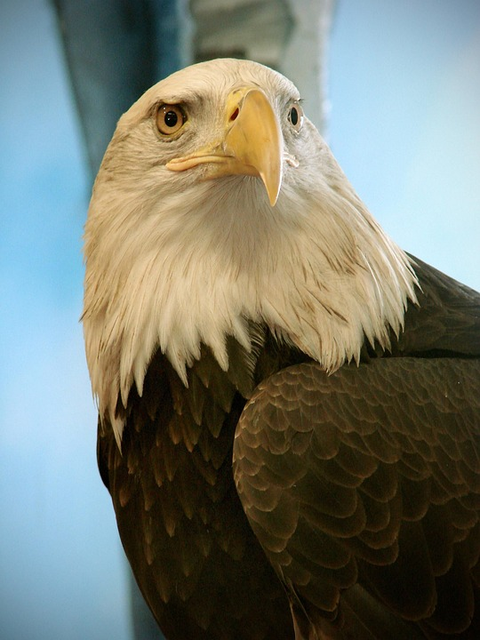

As the day wore on, the sun began to lower in the sky, casting long shadows across the landscape. The warm golden light of late afternoon bathed everything in a soft glow, turning the town into a living painting. People began to retreat into their homes to prepare for dinner, but no one was in a hurry. There was no need to rush when the evening was as calm and beautiful as this. The gentle breeze rustled

😂

the leaves of the trees, carrying with it the promise of a peaceful night. As dusk approached, the sky slowly transformed from deep blue to violet, and the first stars appeared one by one, winking down from the heavens.

The town seemed to sigh, settling in for another tranquil evening. In the distance, the faint sound of a bell tolled, marking the passing of time with a soft, melodious chime. The last few residents lingered outside, chatting on their porches or walking along the quiet streets. No one locked their doors here, trusting in the safety of the community. The night, cool and quiet, wrapped itself around the town like a warm blanket, and for a brief moment, the entire world felt still. As the stars twinkled above and the moon rose high in the sky, the town was at peace, its simple beauty reflected in every quiet corner.